EXPT NO:8 | FORECASTING AND PREDICTIVE ANALYTICS USING TABLEAU AND POWER BI
DATE: 14.08.2026

PRE-LAB QUESTIONS (PROVIDE BRIEF ANSWERS TO THE FOLLOWING QUESTIONS)

- What is forecasting in the context of Business Intelligence (BI)?

Forecasting is the process of using historical data and statistical techniques to predict future trends or outcomes. In BI, it helps businesses estimate future sales, revenue, demand, and other important performance measures.

- Explain the difference between predictive analytics and descriptive analytics.

- Descriptive analytics explains what has happened in the past using historical data, reports, and dashboards.
- Predictive analytics uses historical data, statistical methods, and machine learning to predict what is likely to happen in the future.

- Name two common forecasting methods used in Tableau and Power BI.

- Time-series forecasting – predicts future values based on historical trends over time.
- Moving average – smooths historical data to identify trends and estimate future values.

- Why is data granularity important for accurate forecasting?

Data granularity determines the level of detail in the data, such as daily, monthly, or yearly. Appropriate granularity helps identify trends and seasonal patterns accurately. Too much or too little detail can reduce forecasting accuracy.

- Name two challenges in forecasting using multiple data sources.

- Inconsistent data formats or time periods between different sources.
- Missing, duplicate, or mismatched data, which can affect the accuracy of the forecast.

IN-LAB EXERCISE:
OBJECTIVE:
To perform time series forecasting and predictive analytics on historical sales data using Tableau and Power BI, and visualize future trends for informed decision-making.

PROCEDURE:
- Data Collection:
  - Import historical sales data from multiple sources:
    - Dataset 1: Sales Data (CSV) → Order ID, Order Date, Region, Sales Amount
    - Dataset 2: Promotions Data (Excel) → Promotion ID, Region, Promotion Start Date, Promotion End Date, Discount
- Data Preparation and Transformation:
  - Clean data: standardize date formats, remove duplicates, handle missing values.
  - Aggregate sales data at the required granularity (daily, weekly, or monthly).
  - Ensure numeric fields (Sales, Discount) are correct.
- Data Integration and Modeling:
  - Tableau: Connect datasets and relate them using the Region field.
  - Power BI: Create relationships in the Model view; define cardinality where necessary.
- Forecasting and Predictive Analytics:
  - Tableau:
    - Use the Forecast feature on Sales over time.
    - Apply trend models like Exponential Smoothing and visualize prediction intervals.
  - Power BI:
    - Use built-in forecasting in line charts.
    - Optionally, create a DAX measure for predicted sales using moving averages or linear regression.
- Create Calculated Fields:
  - Forecasted Sales = Predicted value from the model
  - Sales Growth % = ((Forecasted Sales – Actual Sales) / Actual Sales) * 100
- Design a Comprehensive Dashboard:
  - Line chart showing actual vs. forecasted sales over time.
  - KPI cards: Total Forecasted Sales, Expected Growth %.
  - Use combo charts to show sales trends along with promotion periods.
  - Highlight regions with expected growth above or below target thresholds.

- Validate Forecast Accuracy:
  - Compare forecasts against actual historical sales (back-testing).
  - Adjust forecasting parameters if necessary (e.g., seasonality length, smoothing factor).
- Publishing and Sharing:
  - Tableau: Publish workbook to Tableau Public or Tableau Server.
  - Power BI: Publish report to Power BI Service and share with stakeholders.
Experiment Datasets:
  - Dataset 1: Historical Sales Data (CSV) → Order ID, Order Date, Region, Sales
  - Dataset 2: Promotions Data (Excel) → Promotion ID, Region, Promotion Start/End Date, Discount

Power BI:

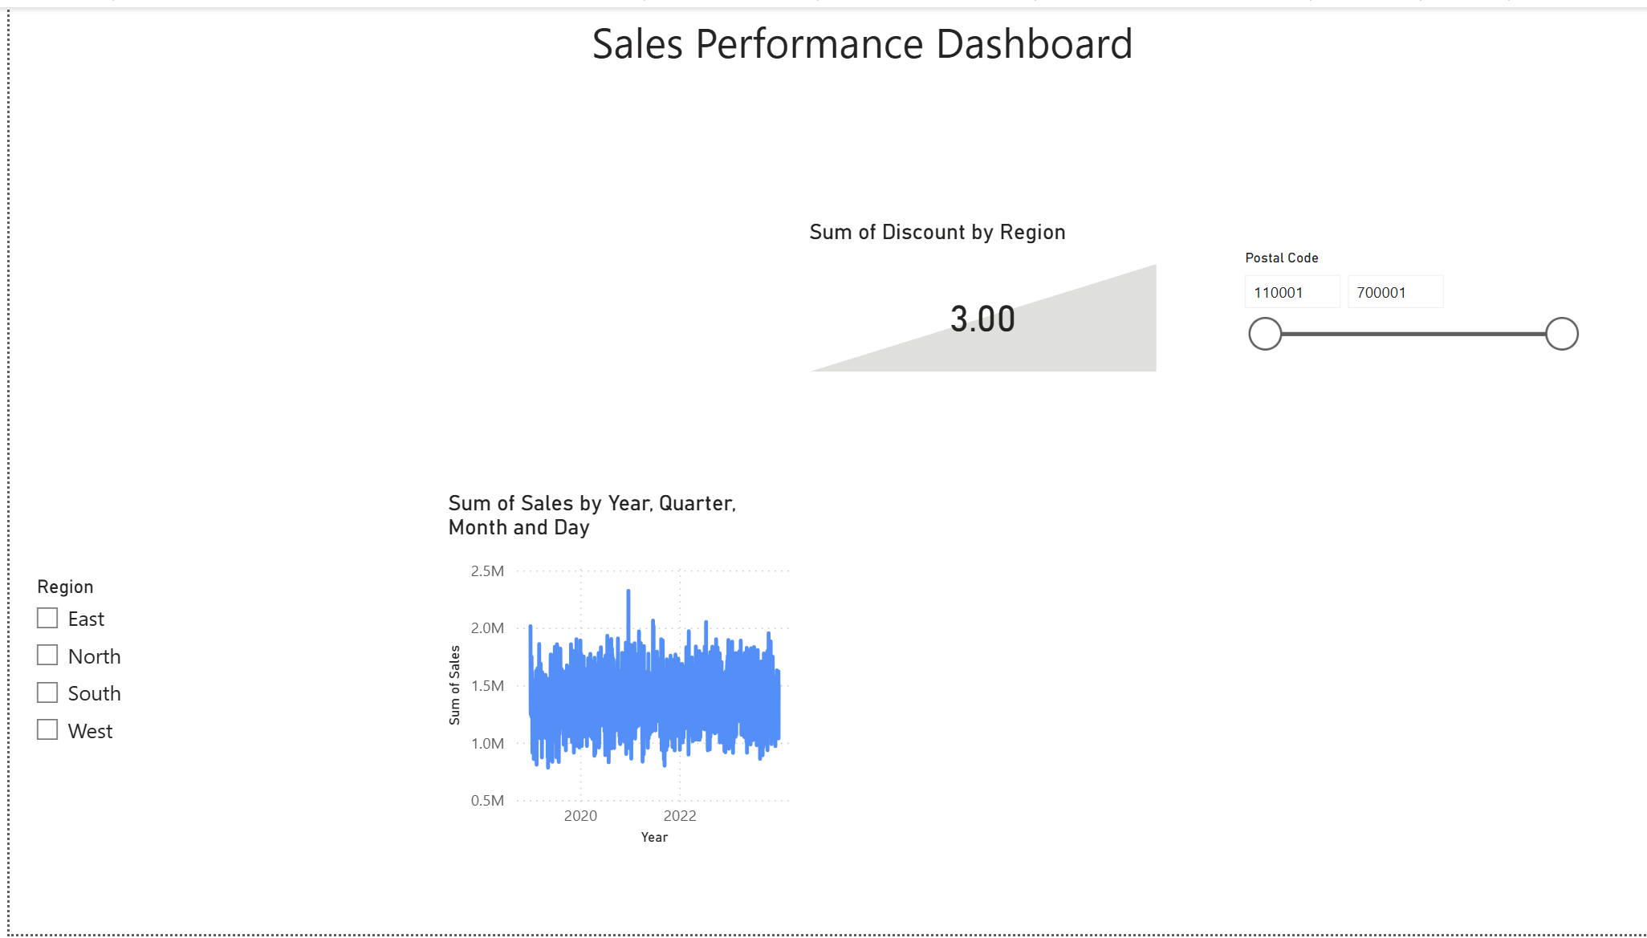

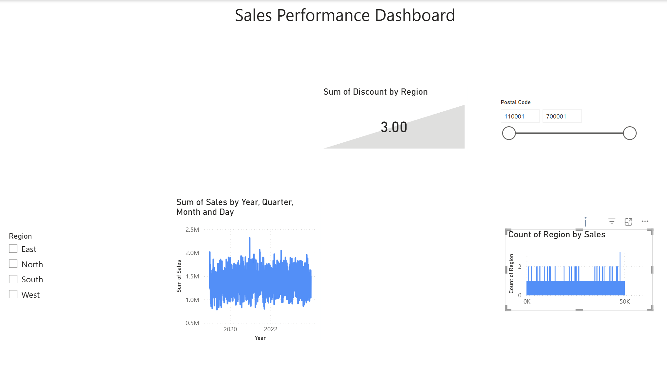

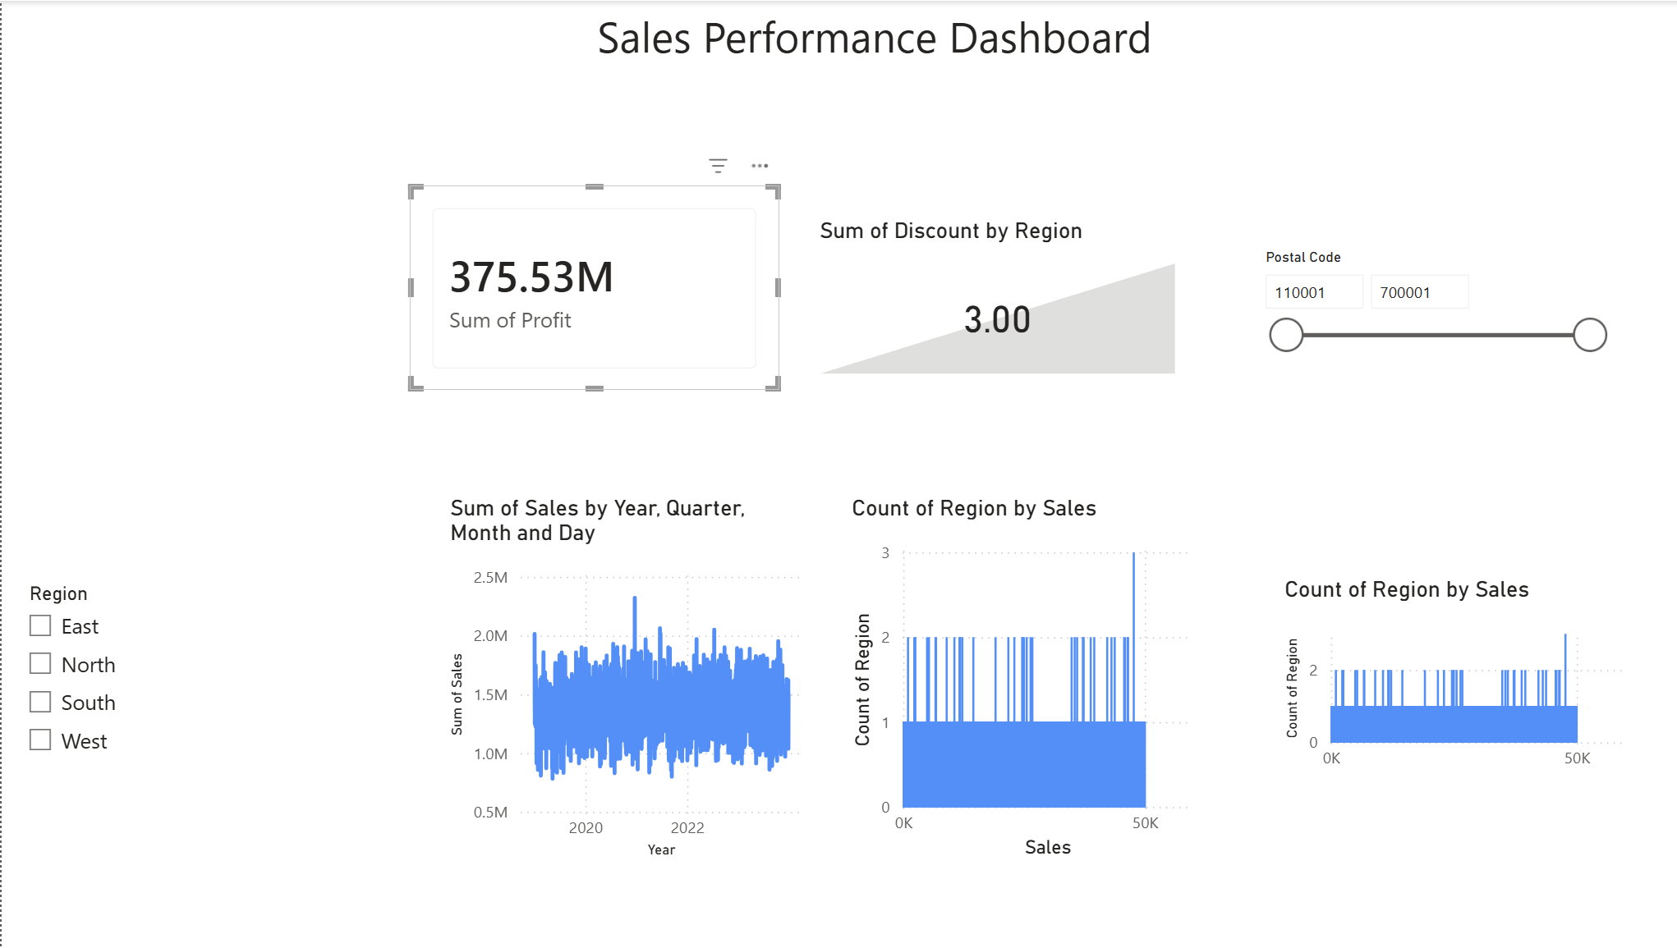

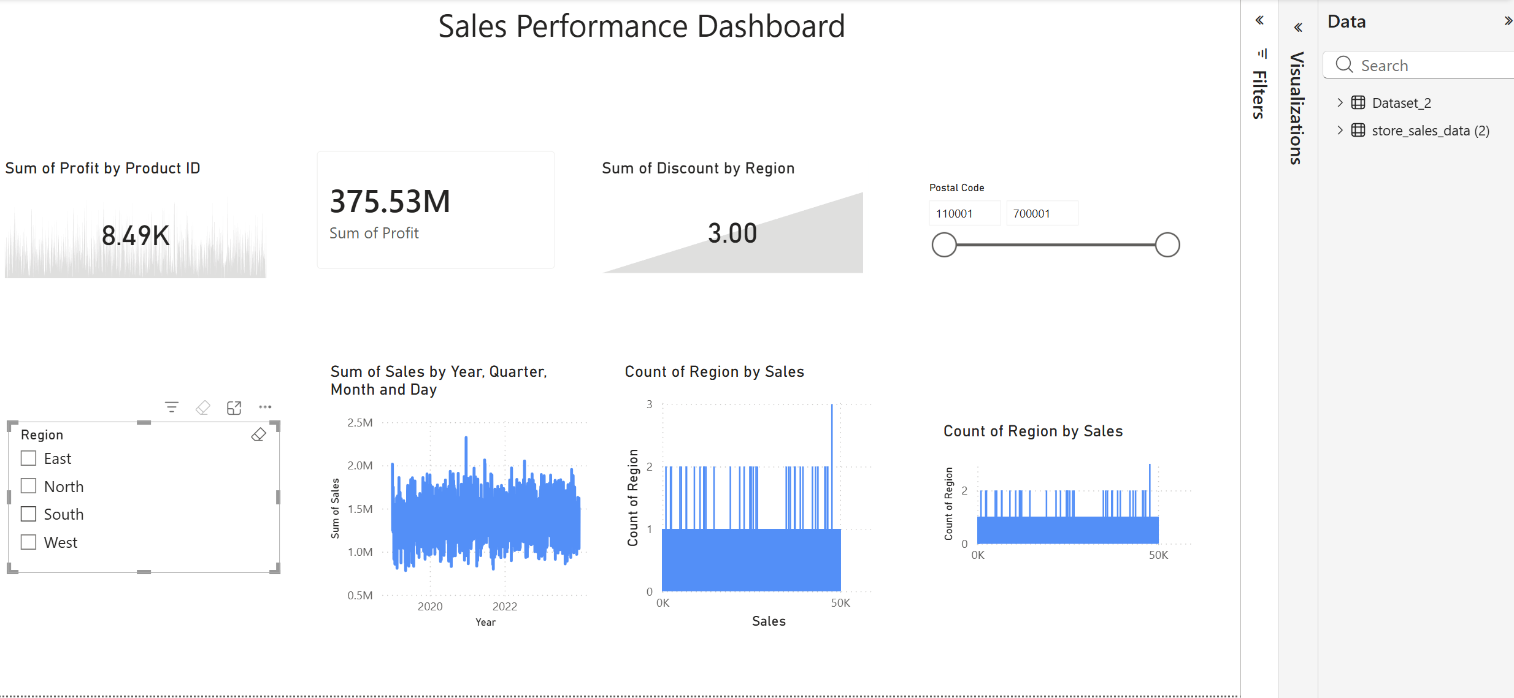

Tableau:

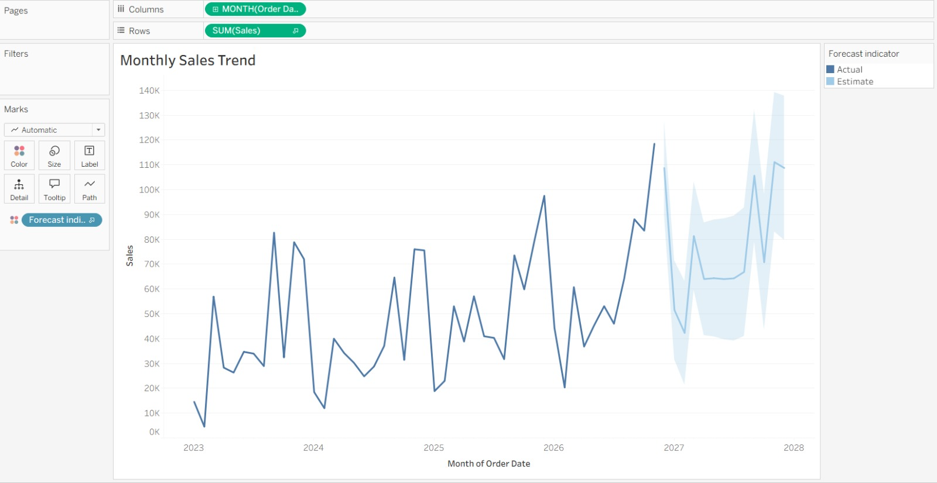

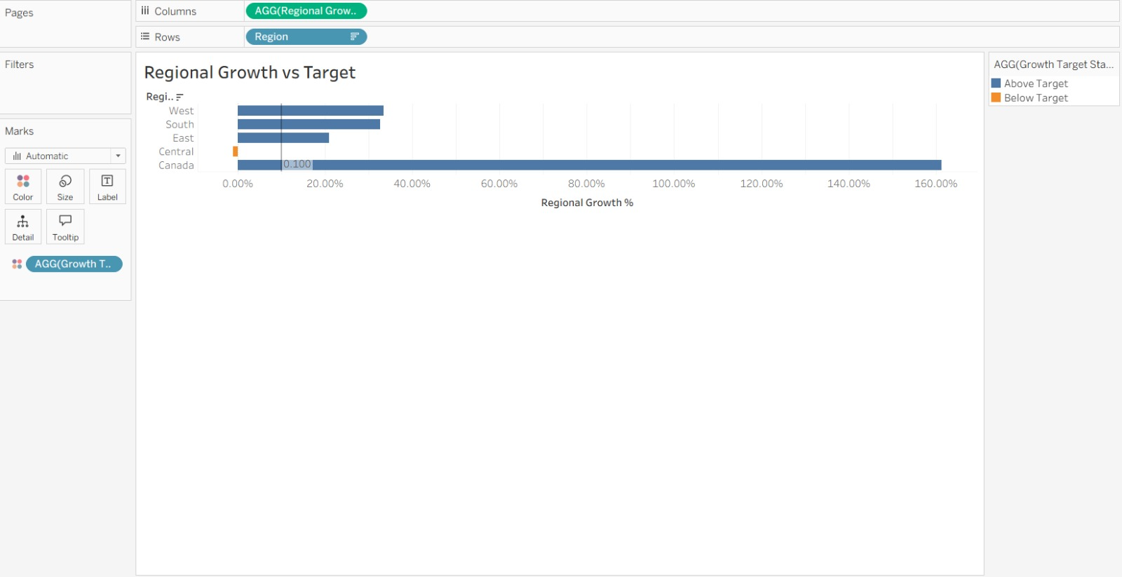
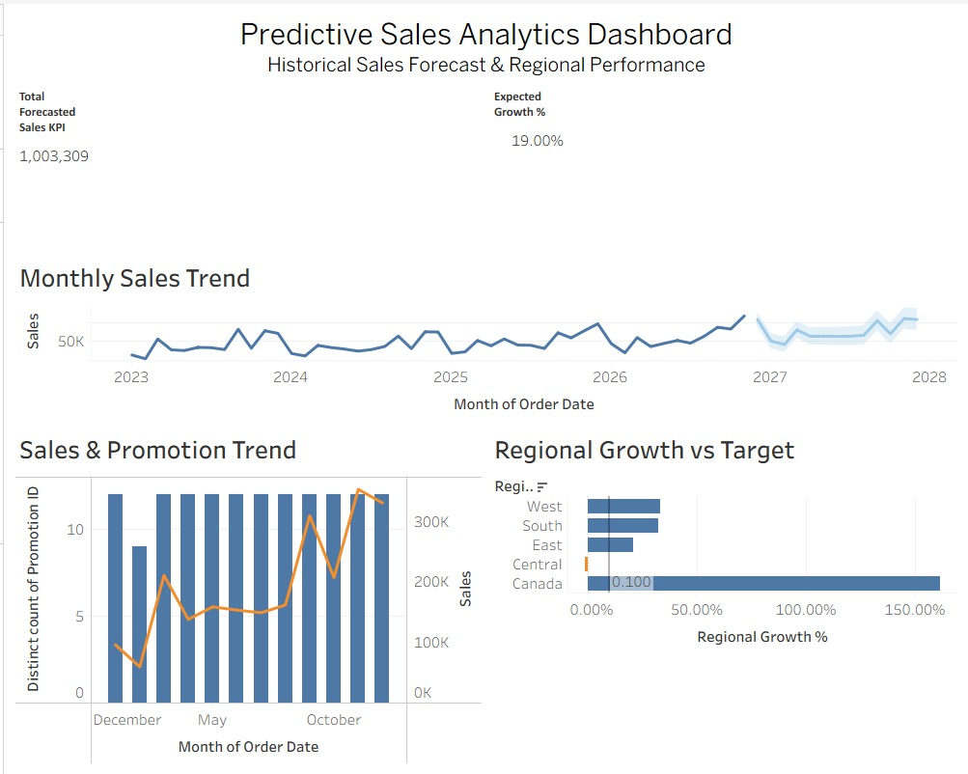

POST-LAB QUESTIONS (PROVIDE BRIEF ANSWERS TO THE FOLLOWING QUESTIONS)
- How did forecasting help in predicting future sales trends for business planning?
Forecasting helped estimate future sales based on historical sales patterns and trends. This allows the business to plan inventory, staffing, budgets, and marketing activities more effectively. It also helps identify periods of expected high or low sales

- What forecasting method did you use, and why was it suitable for the dataset?

I used time-series forecasting because the dataset contains sales values recorded over time. This method was suitable because it can identify historical trends and patterns and use them to estimate future sales.

- What challenges, if any, did you face regarding missing data or irregular time intervals?

One challenge was ensuring that the sales data had consistent time intervals. Missing values or irregular dates could affect the forecast. The data needed to be checked and cleaned before applying the forecasting method.
- How can predictive analytics influence decision-making in a retail environment?

Predictive analytics helps retailers anticipate future demand, customer behavior, and sales trends. Managers can use these predictions to optimize inventory, plan promotions, adjust pricing, and reduce the risk of overstocking or stock shortages.

- What additional data (e.g., competitor pricing, economic indicators) could be integrated to improve forecast accuracy?

Competitor pricing and economic indicators could be integrated with the sales data. Competitor prices can show how market competition affects sales, while economic indicators can help identify broader factors that may influence customer spending and demand.

RESULT:
The historical sales and promotions datasets were successfully cleaned, integrated, and modeled in Tableau and Power BI. Forecasting techniques provided predicted sales trends, growth percentages, and region-wise performance expectations. The resulting dashboards allowed managers to visualize actual vs. forecasted sales, enabling better planning and data-driven decision-making.

ASSESSMENT

Description | Max Marks | Marks Awarded
Pre Lab Exercise | 5
In Lab Exercise | 10
Post Lab Exercise | 5
Viva | 10
Total | 30
Faculty Signature

